

Q-Learning Management System
User manual

How to add a new practical learning outcome
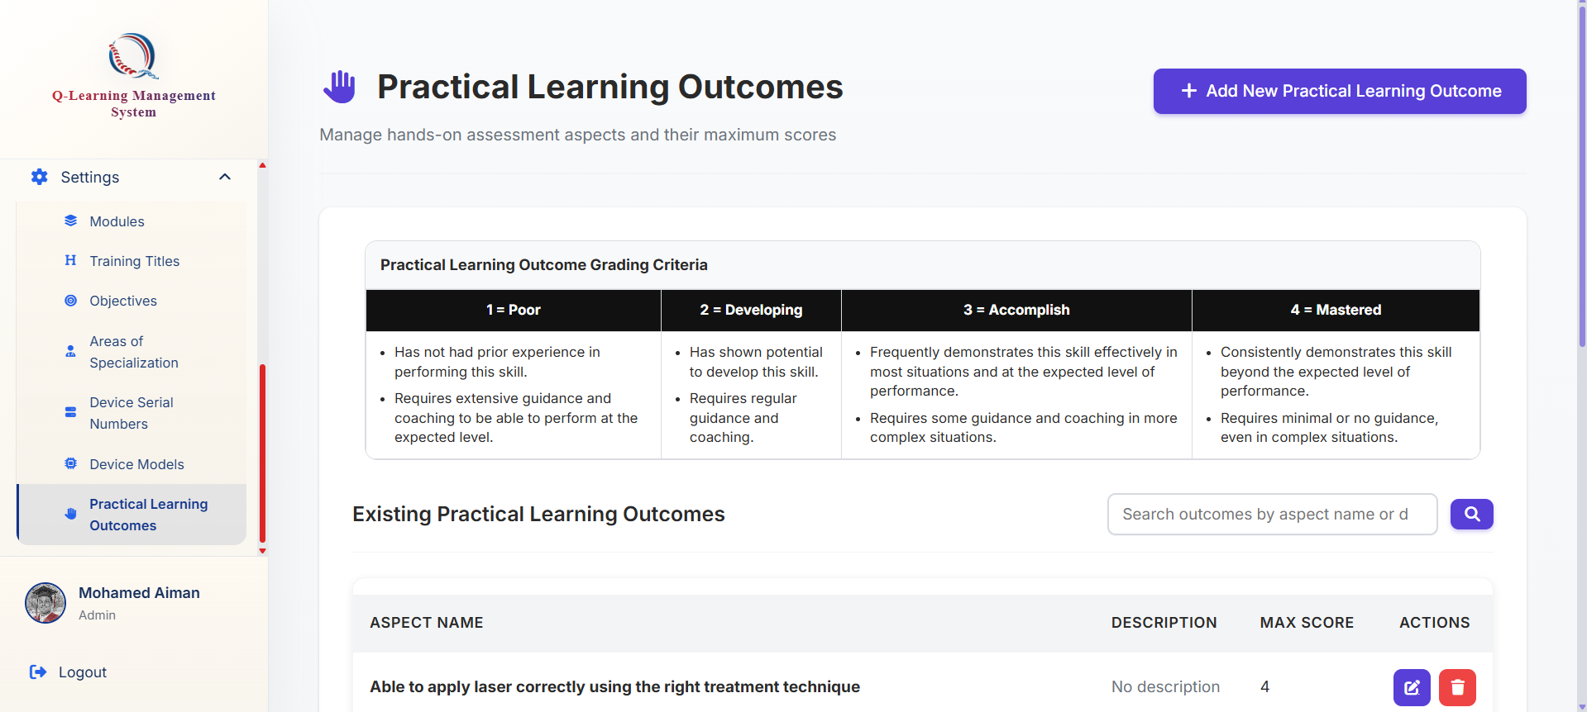

Click on the add new practical learning outcome button
Go ahead to the Practical Learning Outcome tab at the bottom of the sidebar

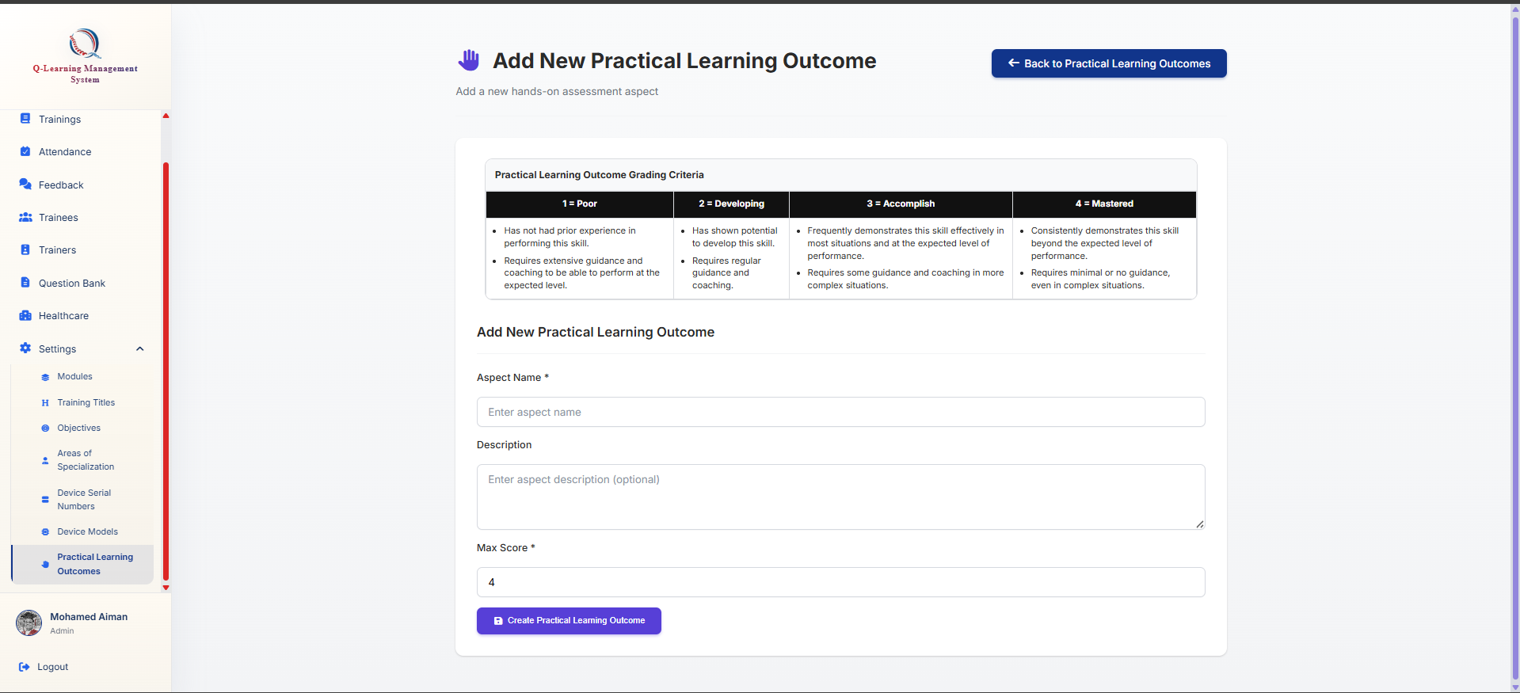
Click on this button to submit and create
You may use the grading criteria here to assess how much is adequate for a outcome.
You will be brought to this form where you may fill up the details needed

